Week 6- ReactJS HOL-Hands On
__________________________________________________________________

1.ReatJS-HOL
Create a new React Application with the name “myfirstreact”, Run the application to print “welcome to the first session of React” as heading of that page.

1.Installed Node.js and npm from the following link: https://nodejs.org/en/download/

2.I installed create-react-app by running the following command in the command prompt:
npm install -g create-react-app

3.Created a new React application named myfirstreact using the following command:
npx create-react-app myfirstreact
4.Once the app was created, I navigated into the folder using the command:
cd myfirstreact
5. Opened the myfirstreact folder in Visual Studio Code.

6.I opened the App.js file located inside the src folder.

- I had removed the existing content from the App.js file.

- I replaced it with the following code:

import React from 'react';
function App() {
return (
<div>
<h1>Welcome to the first session of React</h1>
</div>
);
}
export default App;

- I ran the application using the following command:
npm start

- Finally, I opened a browser window and visited http://localhost:3000 to view the output.

OUTPUT:
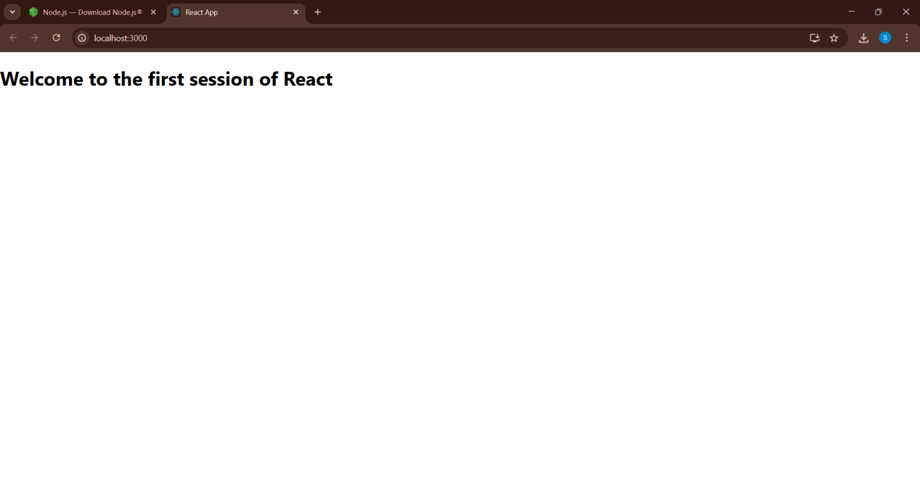

Terminal:

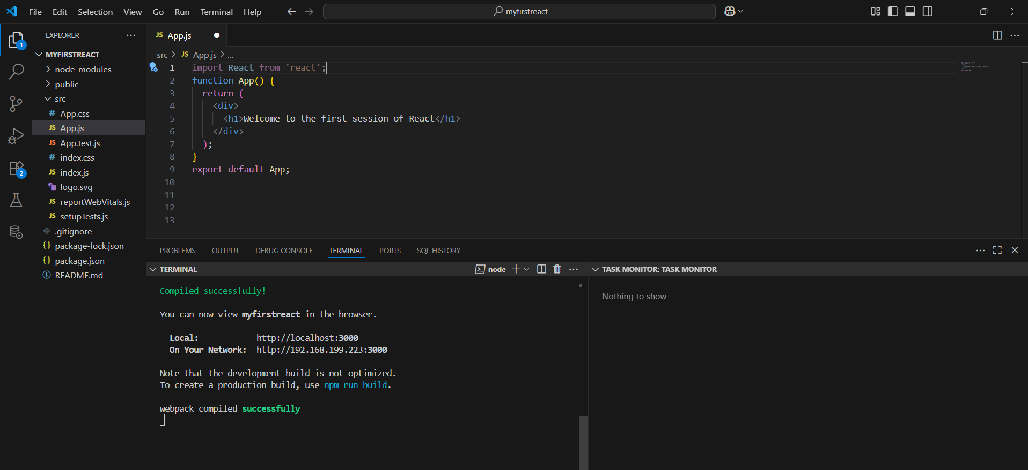

2.ReactJS-HOL
Create a react app for Student Management Portal named StudentApp and create a component named Home which will display the Message “Welcome to the Home page of Student Management Portal”. Create another component named About and display the Message “Welcome to the About page of the Student Management Portal”. Create a third component named Contact and display the Message “Welcome to the Contact page of the Student Management Portal”. Call all the three components.

1.Created a new React project named "StudentApp" using the terminal in Visual Studio by executing the following command
npx create-react-app command.
2.Created a new folder named “Components” under the src directory and added a new file named Home.js.

3.Added the following code inside Home.js.
import React from 'react';
function Home() {
return (
<div>
<h1>
Welcome to the Home page of Student Management Portal
</h1>
</div>
);
}
export default Home;

4.Created another file named About.js under the src folder.

5.Repeated the same process to create the About.js and Contact.js components under the src folder. Edited each file with code similar to the Home component.

About.js
import React from 'react';
function About() {
return (
<div>
<h1 style={{ color: 'red'}}>
Welcome to the About page of the Student Management Portal
</h1>
</div>
);}
export default About;

Contact.js
import React from 'react';
function Contact() {
return (
<div>
<h1 style={{ color: 'blue'}}>
Welcome to the Contact page of the Student Management Portal
</h1>
</div>
);
}
export default Contact;

→In About.js and Contact.js I have added style={{ color: 'red'}} and style={{ color: 'blue'}} to change the color of the text.

- Modified the App.js file to invoke the Home, About, and Contact components.
App.js
import React from 'react';
import './App.css';
import Home from './Components/Home';
import About from './Components/About';
import Contact from './Components/Contact';
function App() {
return (
<div className="App">
<Home />
<About />
<Contact />
</div>
); }
export default App;

7.In command Prompt, navigated into StudentApp and executed the code by using following command
npm start
8.Tested the application by opening a web browser to view the working Student Management Portal.

OUTPUT:

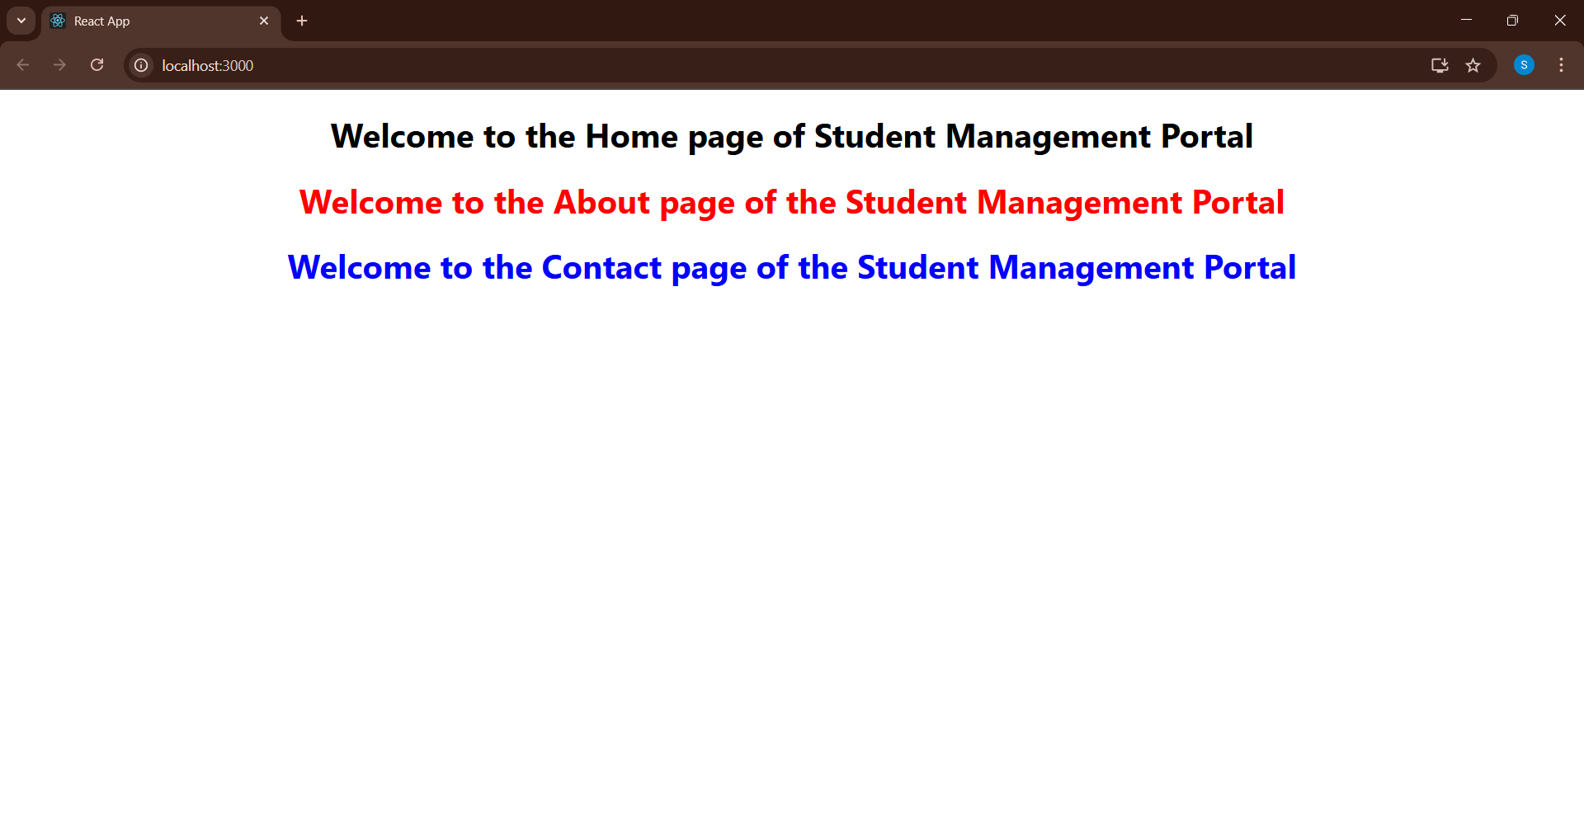

Terminal:

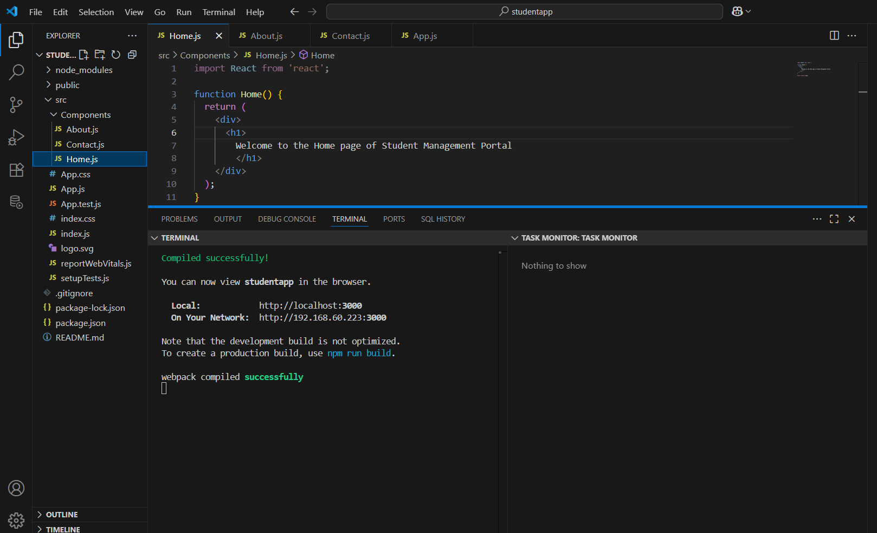
3.ReactJS-HOL
Create a react app for Student Management Portal named scorecalculatorapp and create a function component named “CalculateScore” which will accept Name, School, Total and goal in order to calculate the average score of a student and display the same.

1.Created a React project named “scorecalculatorapp” by executing the following command in terminal of Visual studio:
npx create-react-app scorecalculatorapp
- Created a new folder under Src folder with the name “Components”
and created a new file named “CalculateScore.js” under Components folder.
- Added the following code in CalculateScore.js.

CalculateScore.js
import '../Stylesheets/mystyle.css';
const percentToDecimal = (decimal) => {
return (decimal.toFixed(2) + '%');
};
const calcScore = (total, goal) => {
return percentToDecimal(total / goal);
};
export const CalculateScore = ({ Name, School, total, goal }) => {
return (
<div className="formatstyle">
<h1><font color="Brown">Student Details:</font></h1>
<div className="Name">
<b><span>Name: </span></b>
<span>{Name}</span>
</div>
<div className="School">
<b><span>School: </span></b>
<span>{School}</span>
</div>
<div className="Total">
<b><span>Total: </span></b>
<span>{total}</span>
<span> Marks</span>
</div>
<div className="Score">
<b>Score: </b>
<span>{calcScore(total, goal)}</span>
</div>
</div>
);
};

4.Created a Folder named Stylesheets and created a file named “mystyle.css” under Stylesheets folder.

mystyle.css
.Name {
font-weight: 300;
color: blue;
}
.School {
color: crimson;
}
.Total {
color: darkmagenta;
}
.formatstyle {
text-align: center;
font-size: large;
}
.Score {
color: forestgreen;
}

5.Modified the App.js as follows:

App.js
import { CalculateScore } from './Components/CalculateScore';
function App() {
return (
<div>
<CalculateScore
Name="Jasmitha"
School="Sri Vidya Public School"
total={285}
goal={3}
/>
</div>
);
}
export default App;

6.Ran the scorecalculatorapp application by executing the command:
npm start

OUTPUT:

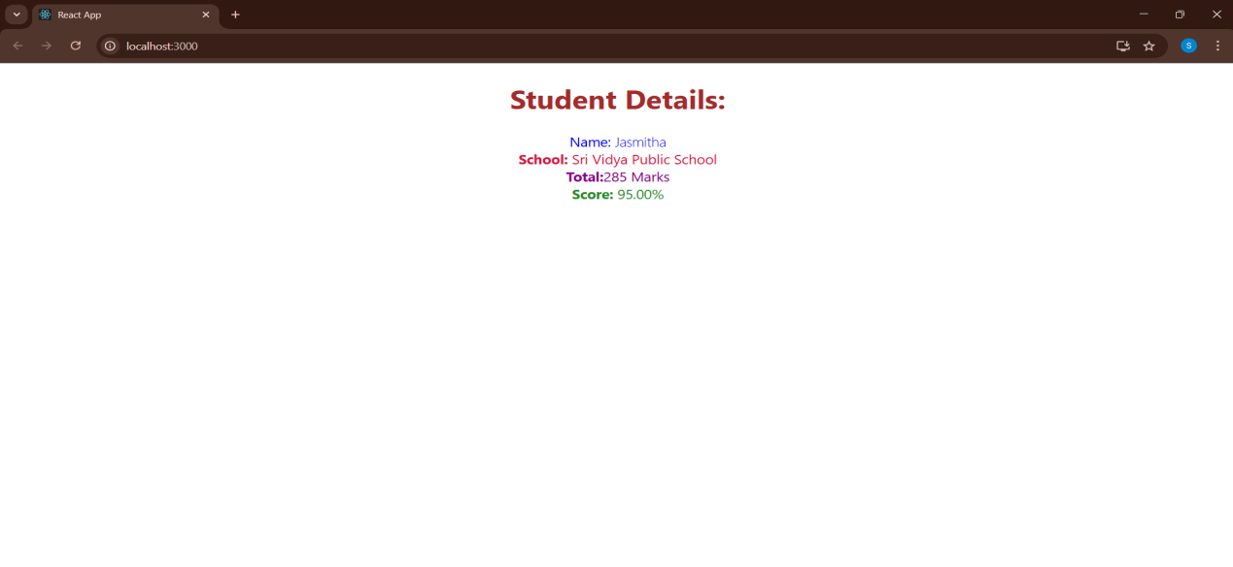

Terminal:
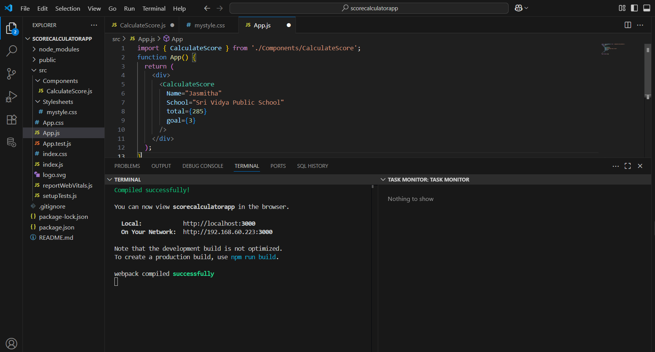
- ReactJS-HOL

- Created a new react application named “blogapp” by executing the command:
npx create-react-app blogapp

- Opened the application using VS Code.

- Created a new file named as Post.js in src folder with following properties.

Post.js
class Post {
constructor(id, title, body) {
this.id = id;
this.title = title;
this.body = body;
}
}
export default Post;

- Created a new file named Posts.js inside src folder

Posts.js
class Posts extends React.Component {
constructor(props) {
super(props);
}
}

- Initialized the component with a list of Post in state of the component using the constructor.

constructor(props) {
super(props);
this.state = {
posts: []
};
}

- Created a method in component with the name as loadPosts() and used the url (https://jsonplaceholder.typicode.com/posts) to get posts.

loadPosts() {
fetch('https://jsonplaceholder.typicode.com/posts')
.then(response => response.json())
.then(data => {
const postList = data.map(item => new Post(item.id, item.title,
item.body));
this.setState({ posts: postList });
})
.catch(error => {
alert('Error fetching posts: ' + error.message);
});
}

- Implemented the componentDidMount() to make calls to loadPosts() which will fetch the posts.

componentDidMount() {
this.loadPosts();
}

- Implemented the render() which will display the title and post of posts in html page using heading and paragraphs.

render() {
return (
<div>
<h1>Blog Posts</h1>
{this.state.posts.map(post => (
<div key={post.id}>
<h2>{post.title}</h2>
<p>{post.body}</p>
<hr />
</div>
))}
</div>
);
}

- Define a componentDidCatch() method which will be responsible for displaying any error happing in the component as alert messages.

componentDidCatch(error, info) {
alert('Something went wrong in Posts component!');
console.error(error, info);
}

10.Added the Posts component to App component.

App.js
import React from 'react';
import './App.css';
import Posts from './Posts';
function App() {
return (
<div className="App">
<Posts />
</div>
);
}
export default App;

11.Ran the application by executing the command:
npm start

OUTPUT:

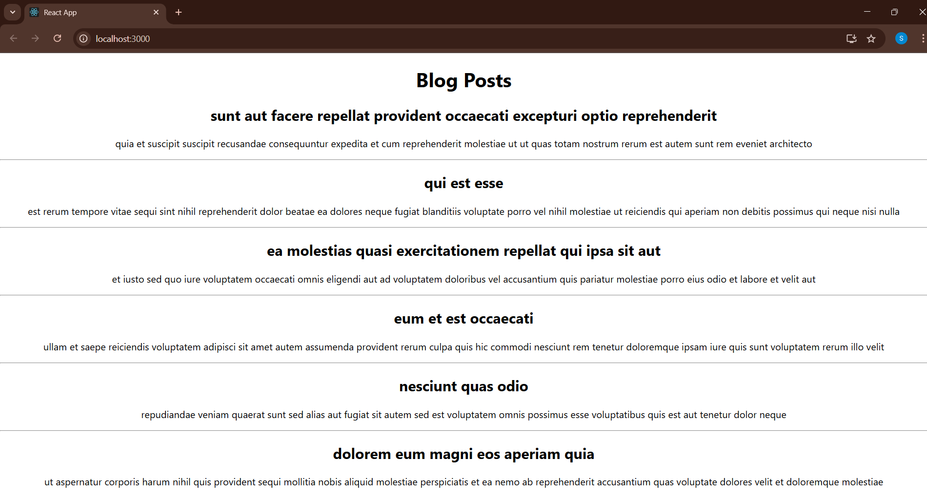

Terminal:

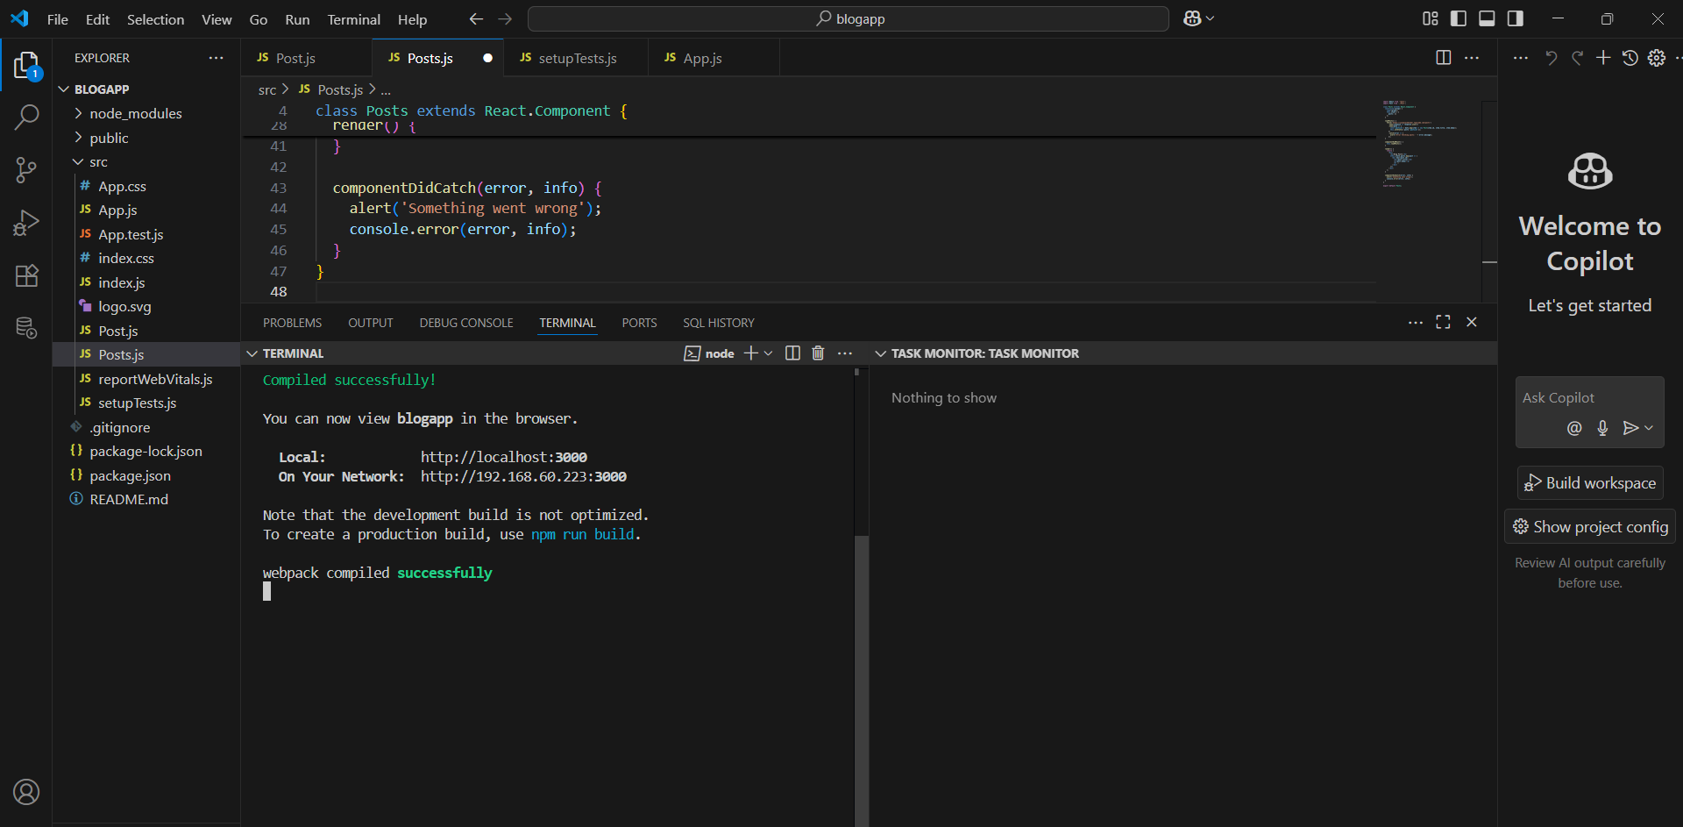

- ReactJS-HOL

- Unzipped the react application.
- Opened command prompt and switched to the react application folder.
- Restored the node packages by executing the command:
npm install
4.Opened the application using VS Code
5.Created a new CSS Module in a file called “CohortDetails.module.css”
6.Defined a css class with the name as “box” with following properties.
.box {
width: 300px;
display: inline-block;
margin: 10px;
padding: 10px 20px;
border: 1px solid black;
border-radius: 10px;
vertical-align: top;
text-align: left;
}
7.Defined a css style for html <dt> element using tag selector. Set the font weight to 500.
dt {
font-weight: 500;
}
8.Opened the cohort details component and import the CSS Module
9.Applied the box class to the container div
10.Defined the style for <h3> element to use “green” color font when cohort status is “ongoing” and “blue” color in all other scenarios.
import React from 'react';
import styles from './CohortDetails.module.css';
function CohortDetails(props) {
const { cohort } = props;
const titleColorClass =
cohort.currentStatus.toLowerCase() === 'ongoing' ? styles.green : styles.blue;
return (
<div className={styles.box}>
<h3 className={titleColorClass}>{cohort.name}</h3>
<dl>
<dt>Started On</dt>
<dd>{cohort.startDate}</dd>
<dt>Current Status</dt>
<dd>{cohort.currentStatus}</dd>
<dt>Coach</dt>
<dd>{cohort.coachName}</dd>
<dt>Trainer</dt>
<dd>{cohort.trainerName}</dd>
</dl>
</div>
);
}
export default CohortDetails;
OUTPUT:

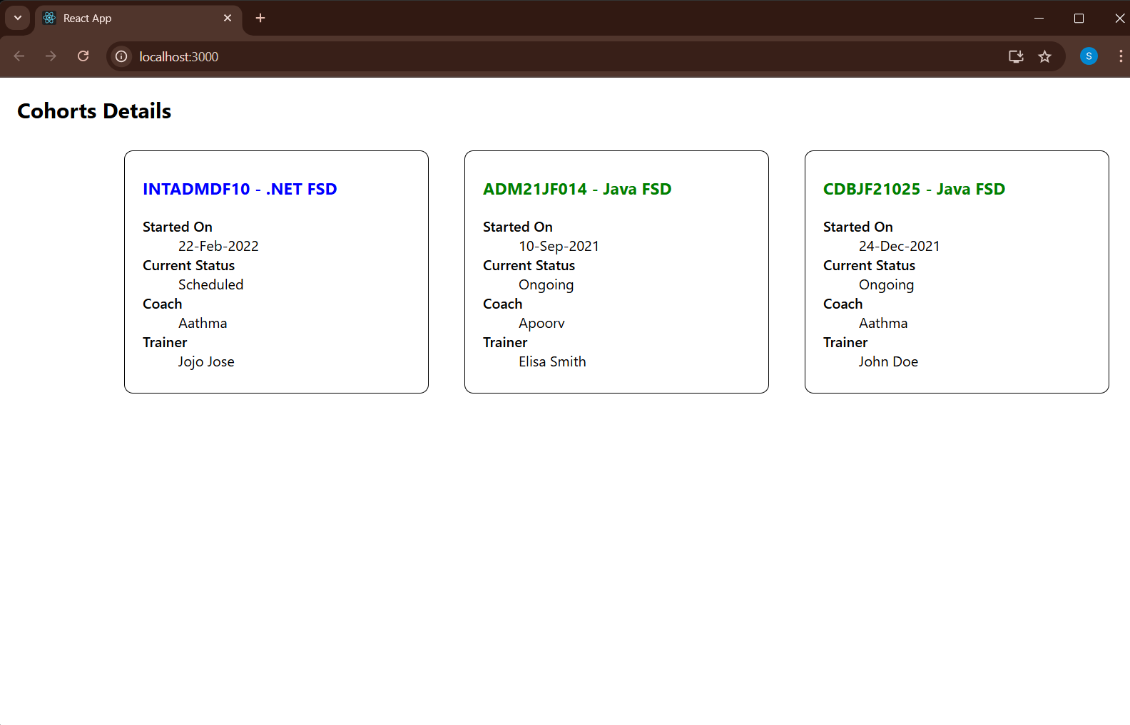

Terminal:

